Condition Loops

Look at this code:
target = 7
attempts = 0
guess = 0
while guess != target and attempts < 3:
guess = int(input("Guess 1 to 10: "))
attempts = attempts + 1
print("Finished in", attempts, "tries.")

What do you think this code will do for guesses 5 and 7?
Click or tap here to enter text.

Run the code. Compare the result with your prediction:
Click or tap here to enter text.

Let’s investigate! Answer the questions below:
- Which two stored values change each time the loop runs?
Click or tap here to enter text.

- Why does the terminating guess still increase the attempt counter?
Click or tap here to enter text.

- If the guesses are 2 and then 7, what does the final line display?
Click or tap here to enter text.

- Why does the loop stop after three wrong guesses even though the target was not found?
Click or tap here to enter text.

Condition Loops

Look at this code:
target = 7
attempts = 0
guess = 0
while guess != target and attempts < 3:
guess = int(input("Guess 1 to 10: "))
attempts = attempts + 1
print("Finished in", attempts, "tries.")

Use the code above to help you. After completing each challenge below, run your program to test that it works correctly. Save each completed challenge program in a new file.

Programming Challenges

Challenge 1
Choose a new target number. Keep the three-attempt limit, then guess it first and complete another run with three wrong guesses. Check that the program reports 1 try and 3 tries.
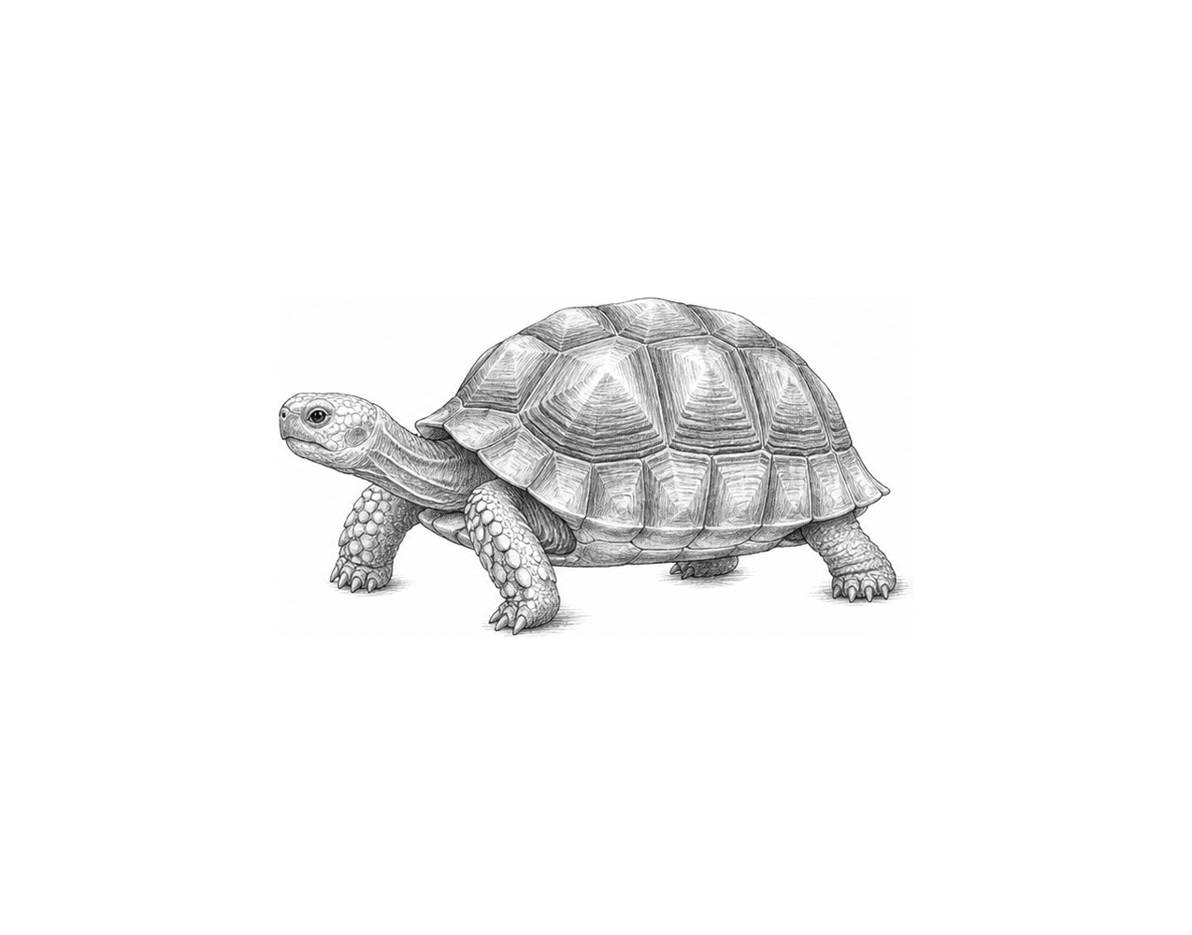

Challenge 2
Give the player five attempts. Update the finishing message to report the guesses used. Test an early correct guess and five unsuccessful guesses; both counts must be accurate.

Challenge 3
Create a door-code checker with a while loop that allows at most three attempts. Stop early when "open" is entered, then display either a success message or a final locked message with the attempts used.

Condition Loops

Fix the code!

This code has errors! Look closely at the code to find the problems:

target = 7
attempts = 0
guess = 0
while guess != target and attempts < 3:
guess = int(input("Guess 1 to 10: "))
attempts = attempts + "1"
print("Finished in", attempts, "tries.")

Rewrite the whole program in the box below with fixes to the errors.
Click or tap here to enter text.

After you are confident that you fixed all the errors, copy the code from the box and run it.

Did it work correctly on your first try? Did you find all the errors?
Click or tap here to enter text.

